**NSDD Drill March 2021 Answers**15 April 2021

LA-UR-21-23546

Approved for public release; distribution is unlimited.

Title: NSDD Drill March 2021 Questions

Author: David J. Mercer and Jennifer L. Auxier

Date: 15 April 2021

This is the NSDD “Flavor of the Month” drill for March 2021. All of the examples involve radiopharmaceuticals that have been approved recently or are undergoing clinical trials. Thank you to the Azerbaijan Nuclear Forensics Team, who supplied one of the examples. This drill has a difficulty level of 5/10.

Question 1: What radionuclide/isomer is visible in the spectrum *Canine*? The product has been approved for treating arthritis in dogs (radiosynovectomy) and is undergoing human trials. It is unique in its therapeutic use of conversion electrons (CE). No background or calibration spectrum is available.

Answer 1: Sn-117m. Radiosynovectomy may also use P-32, Y-90, Er-169, or Re-186. Sn-117m is also undergoing trials for reducing inflammation in arterial plaques. Note that Te-123m has a radiation signature that is very similar to Sn-117m. Sn-117m produces a tiny peak at 156.02 keV that is visible in the spectrum.

Question 2: In the *Canine* spectrum, is the positron annihilation peak at 511.0 keV statistically significant? Is the 391.7 keV peak (from a possible Sn-113 impurity) statistically significant? Explain your answers.

Answer 2: There is no “correct” answer. This question is intended to open a discussion on the meaning of “statistical significance” and procedures for finding the area and uncertainty of very weak peaks. Please send us your comments.

I normally consider a peak to be “statistically significant” if its area is at least three times its uncertainty. This is a “3σ” peak, and corresponds to a 99.7% certainty that the peak exists (or 88.8% certainty under the worst-case Chebyshev assumptions). Some scientists consider “2σ” peaks to be significant.

Using Interspec (which uses Poisson fitting), I find that the peak at 511 keV has a net area of about 19.1 ± 6.8 counts, or 2.8σ. The 391.7 keV peak has an approximate area of 10.8 ± 4.7 counts, or 2.3σ (see plots below). Different fitting regions, algorithms, and assumptions about peak width may give different answers. One responder found areas of 17 ± 5.5 (=3.1σ) and 6 ± 4.6 (=1.3σ) using region-of-interest analysis.

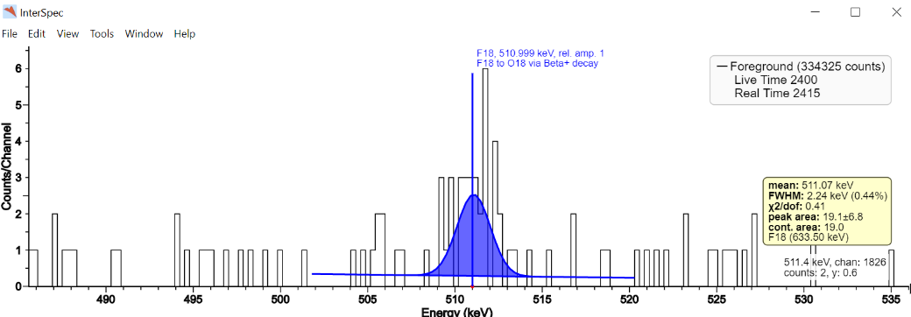

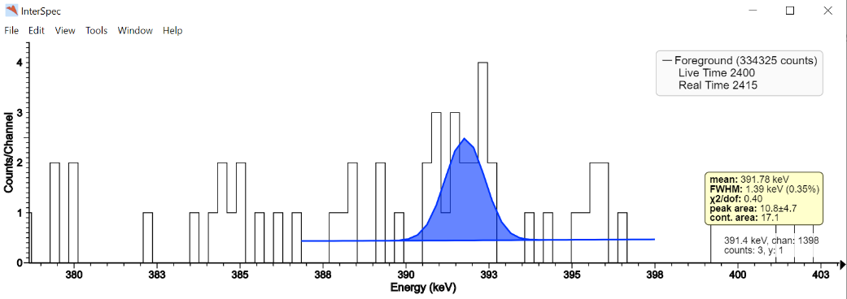

Question 3: A person receiving treatment for bone metastases received a palliative drug made with an alpha-emitting radionuclide. See *Bone IdentiFinder* for a low-resolution spectrum collected with a NaI-based instrument, or *Bone EX200* for a high-resolution spectrum collected with an Ortec Detective EX-200 instrument. What is the primary radionuclide in this drug? (Note that “primary” means earliest in the decay chain.)

Answer 3: Ra-223. The drug is Xofigo® which is becoming more popular, partly replacing Sr-89 MetastronTM and Sm-153 Quadramet® for treatment of bone pain.

The peaks marked below are from Ra-223, Rn-219, Pb-211, and Bi-211. Po-215 gamma signatures are weak. Po-211/Tl-207 is visible at 897.8 keV. The signature of Th-227 is notably absent at 235.97 keV.

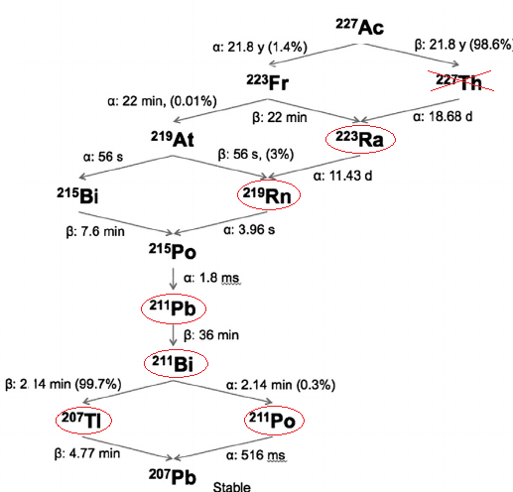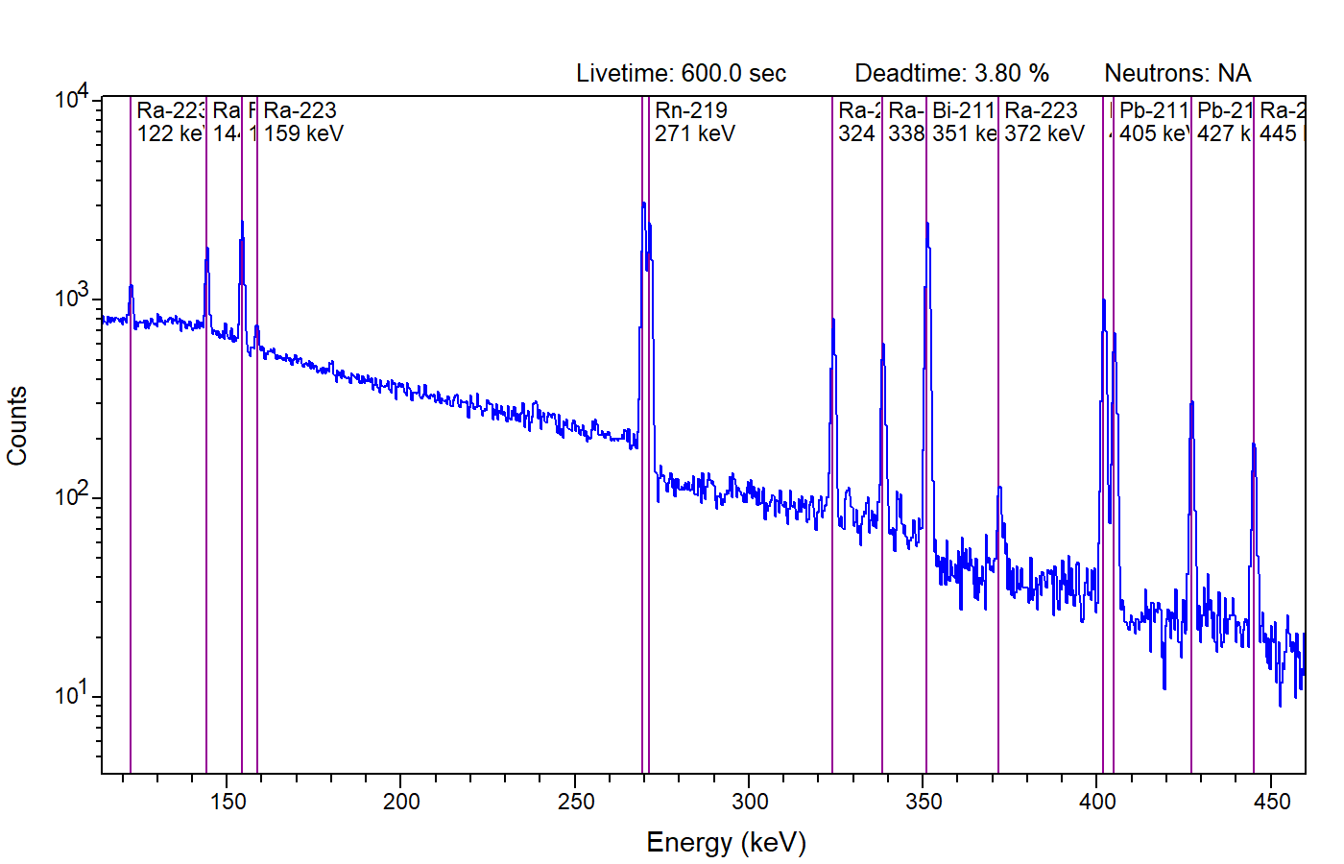

Question 4: Estimate the activity in becquerels (decays/s) of the primary radionuclide from the previous question. You may use the following information:

Measurement live time: 600 s

Measurement distance: 100 cm

Net counts in 154.2 keV Peak: 6408 counts

Detection efficiency at 154.2 keV and 100 cm: 2.713×10−4 counts/gamma

Yield of 154.2 keV gammas from primary radionuclide: 5.617×10−2 gammas/decay

Answer 4: 7.01 x 105 Bq. This is found from

$$Activity= \frac{Net Counts}{Time ×Efficiency ×Yield}=\frac{6408 counts}{600 s × 2.713×{10}^{-4}\frac{counts}{gamma} ×5.617×{10}^{-2}\frac{gammas}{decay} }$$

$$=700837 decay/s$$

Additional Exercise: gamma ray attenuation is also an important factor in the calculation of activity. Gamma rays are attenuated by a factor of e-μx where μ is the linear attenuation coefficient and x is the thickness of the attenuator. The thickness is unknown in this case but it can be estimated from the data. Water is a reasonable substitute for human tissue.

The table below gives the gamma ray yield, detector efficiency, and linear attenuation coefficient for water at three different energies. You may extract peak areas from the *Bone EX200* spectrum. What thickness of water gives approximately the same corrected activity for all three energies? See the graph below. How large is the correction at 154.21 keV?

|  |  |  |  |
| --- | --- | --- | --- |
| Energy  (keV) | Yield  (gammas/decay) | Detector Efficiency at 100 cm  (counts/gamma) | μ for water (1/cm) |
| 154.21 | 0.05617 | 2.713×10-4 | 0.1492 |
| 427.09 | 0.01756 | 1.162×10-4 | 0.1034 |
| 832.01 | 0.03524 | 6.172×10-5 | 0.0772 |

Answer for Additional Exercise: 5.3 ± 0.7 cm is a good estimate for water thickness. At 154.21 keV the correction factor is 2.2. The plot below compares the corrected and uncorrected activities at three energies. Note that 154.21 keV is form Ra-223, but 427.09 keV and 832.01 keV are from Pb-211, so there is an assumption of secular equilibrium.

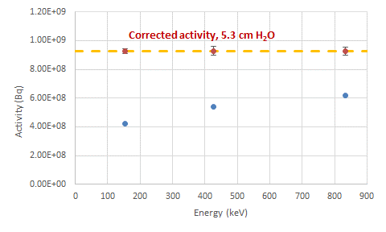

Also, above I have assumed a simple model where the source is shielded by a layer of H2O with thickness *z* rather than being distributed within the layer. In this simple model the corrected activity is found by:

$$Activity≈ \frac{Net Counts}{Time ×Efficiency ×Yield }×\frac{1}{exp⁡(-μ z)}$$

However, if we assume a model where the source is uniformly distributed within a slab of material of thickness *z,* the formula becomes:

$$Activity≈ \frac{Net Counts}{Time ×Efficiency ×Yield } × \frac{μ z}{1-exp⁡(-μ z)}$$

With the distributed model the best fit for thickness *z* is 14 cm and the correction factor is 2.4.

Question 5: What is the primary radionuclide visible in the spectrum *Research Alpha*? This radionuclide is under investigation for antibody-labelled cancer therapy. Clinical trials are in progress, but the supply is of this radionuclide is currently very limited.

Answer 5: Ac-225.

Question 6: Are either Th-229 or U-233 visible in the spectrum *Research Alpha*?

(Presence of these impurities would indicate a serious problem with the chemical processing.)

Answer 6: No. Th-229 was probably the generator for this Ac-225 sample, and U-233 was probably the generator for the Th-229, but neither is visible in the sample. An alternative method of producing Ac-225 may include an Ac-227 contaminant, but this also is not observed in the sample.

Question 7: The radionuclide Cu-67 is under consideration for targeted radioisotope therapy for a wide variety of cancers. Its spectrum, however, has some similarities to U-235, which may cause misidentifications. Of the two spectra, *Argonne A* and *Argonne B*, which spectrum is from Cu-67?

Answer 7: Spectrum B is from Cu-67. Spectrum A is from a laboratory sample of highly enriched uranium (HEU) that is 93% U-235. The spectrum of Cu-67 is easily confused with U-235; however, Cu-67 produces weak peaks at 300.2 and 393.5 keV that are not seen in HEU, and Cu-67 does not produce a peak at 143.8 keV, which may indicate U-235. Cu-67 is not yet approved in any radiopharmaceutical, but it may become a source of innocent alarms in the future. The discriminating peaks are very weak, so a spectrum with low counting statistics will be very difficult to discriminate.

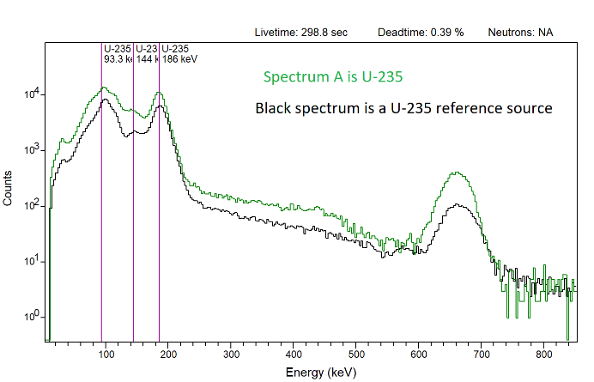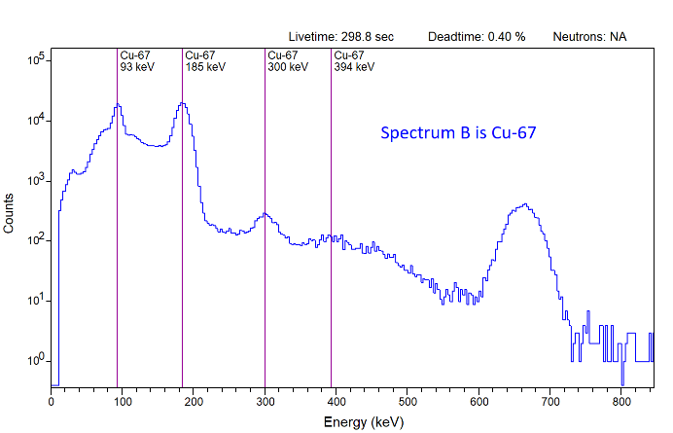

Question 8: The spectrum *Washington NaI* shows a radionuclide that is used for positron emission tomography (PET) imaging. It is also under investigation for therapeutic applications. You may use the higher-resolution spectrum *Washington HPGe* if you prefer. What is this radionuclide?

Answer 8: Cu-64. Although F-18 is the most common PET radionuclide, several other positron-emitters are also used for imaging, and more are used in a research setting.

Question 9: The spectrum *Cardiac PET* was collected with a NaI-based instrument from a person who had a myocardial perfusion scan. What positron-emitting PET radionuclide is evident? Background and Cs-137 calibration spectra are also provided.

Answer 9: Rb-82. This radionuclide is and alternative for Tl-201 and Tc-99m in myocardial perfusion scans, and generally produces higher-quality images.

Question 10: A “generator” is used to provide the PET radionuclide used in Question 9. A saline solution is injected into the generator, and the daughter is extracted while the parent remains immobilized. A spectrum of the device is shown in the spectrum *Generator HPGe.* What radioisotope is visible at an energy slightly higher than 511 keV?

Answer 10: Sr-85. In the generator, the parent radionuclide for Rb-82 is Sr-82, and Sr-85 is an impurity that is always present. Its peak energy is 514.01 keV, identical to Kr-85.

For additional thought: The spectrum *Cardiac PET* fromQuestion 9 was collected 14 days after the myocardial perfusion scan was completed. Is the observed radiation signature consistent with the half-life of the PET radionuclide? What is a possible explanation?

Answer: Breakthrough of the Sr-82 parent radionuclide. The spectrum is from an actual patient who was accidentally injected with Sr-82 from a damaged generator in addition to the desired Rb-82 product. Rb-82 has a half-life of 78 seconds, and is normally not visible after 14 days. Strontium is chemically similar to calcium, and the material was likely incorporated into the patient’s bones. Sr-82 has a half-life of 25 days and continued to produce Rb-82 inside the body. Fortunately, the accidental dose was small enough that the patient was not harmed.

Breakthrough events are extremely rare, but are plausible for medical radionuclide generators. Another example to watch for is Mo-99 breakthrough from a Tc-99m generator, but I have never personally observed this.